ONEWAY SA BY FPS
/STATISTICS DESCRIPTIVES HOMOGENEITY WELCH
/PLOT MEANS
/MISSING ANALYSIS.

Oneway

Notes
Output Created |  | 06-May-2019 00:00:07
Comments
Input | Active Dataset | DataSet0
Input | Filter | <none>
Input | Weight | <none>
Input | Split File | <none>
Input | N of Rows in Working Data File | 30
Missing Value Handling | Definition of Missing | User-defined missing values are treated as missing.
Missing Value Handling | Cases Used | Statistics for each analysis are based on cases with no missing data for any variable in the analysis.
Syntax |  | ONEWAY SA BY FPS  /STATISTICS DESCRIPTIVES HOMOGENEITY WELCH  /PLOT MEANS  /MISSING ANALYSIS.
Resources | Processor Time | 00 00:00:00.187
Resources | Elapsed Time | 00 00:00:00.184

[DataSet0]

Descriptives
 | N | Mean | Std. Deviation | Std. Error | 95% Confidence Interval for Mean
 |  |  |  |  | Lower Bound | Upper Bound
30 FPS | 13 | 29.1538 | 16.20106 | 4.49337 | 19.3636 | 38.9440
60 FPS | 17 | 24.6471 | 17.37074 | 4.21302 | 15.7158 | 33.5783
Total | 30 | 26.6000 | 16.74062 | 3.05640 | 20.3490 | 32.8510

Descriptives
 | Minimum | Maximum
30 FPS | 5.00 | 62.00
60 FPS | 6.00 | 67.00
Total | 5.00 | 67.00

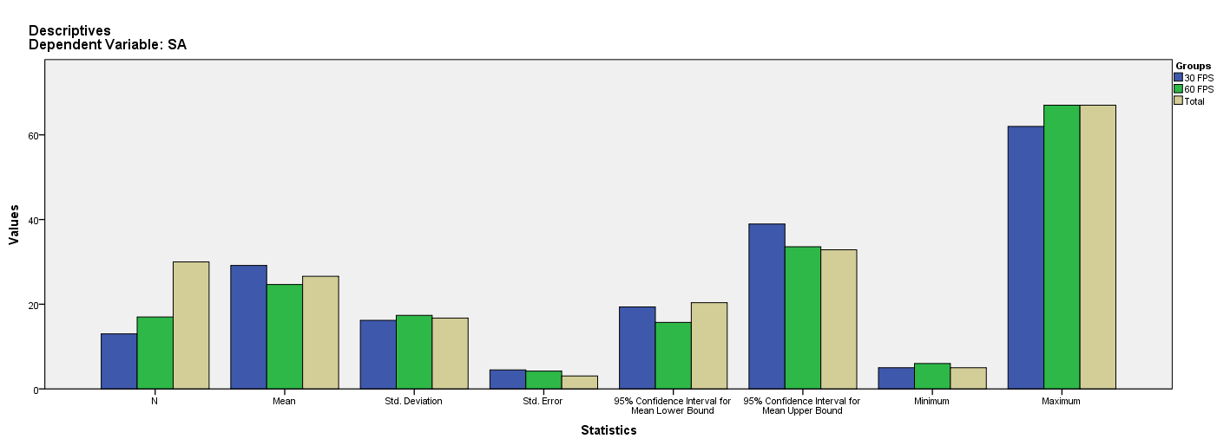

Test of Homogeneity of Variances
SA
Levene Statistic | df1 | df2 | Sig.
.000 | 1 | 28 | .988

ANOVA
SA
 | Sum of Squares | df | Mean Square | F | Sig.
Between Groups | 149.625 | 1 | 149.625 | .525 | .475
Within Groups | 7977.575 | 28 | 284.913
Total | 8127.200 | 29

Robust Tests of Equality of Means
SA
 | Statisticª | df1 | df2 | Sig.
Welch | .535 | 1 | 26.825 | .471
a. Asymptotically F distributed.

Means Plots

